Information content

Alias

surprisal

information content

Def

The information content of event X is defined as follows:

$$I_{X}\left(x\right)$$

= $$−\log\left(p_{X}\left(x\right)\right)$$

Feature

1. $$I_{X}\left(x\right)$$ is strictly decreasing monotonic function.
2. Indepency: If $$X$$ and $$Y$$ are independent, we have that

$$I_{X,Y}\left(x,y\right)$$ = $$I_{X}\left(x\right)+I_{Y}\left(y\right)$$

Property

Log-Odds

logit(x)

= $$I\left(neg\left(x\right)\right)−I\left(x\right)$$

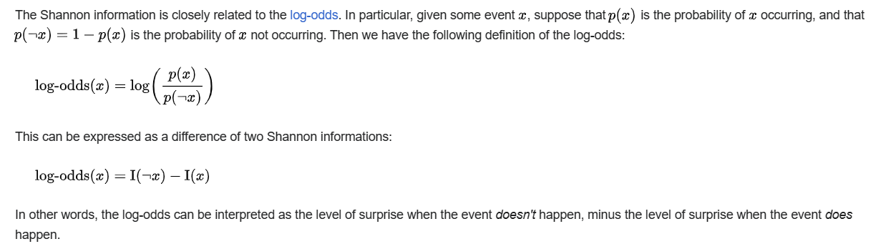

Entropy

$$H\left(x\right)$$

= $$E\left[I_{X}\left(x\right)\right]$$

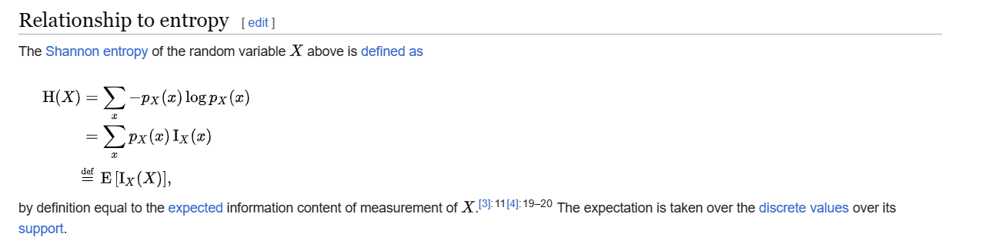

Ref

[Information content - Wikipedia](https://en.wikipedia.org/wiki/Information_content)